**Assignment 01**

**Building a Member Management Application with Windows Forms**

# Introduction

Imagine you're an employee of a product retailer named **FStore**. Your manager has asked you to develop a Windows Forms application for member management: **MemberID, MemberName, Email, Password, City, Country**. The application has a default account whose email is “**admin@fstore.com**” and password is “**admin@@**” that stored in the **appsettings.json.**

The application has to support adding, viewing, modifying, and removing products—a standardized usage action verbs better known as Create, Read, Update, Delete (CRUD). This assignment explores creating an application using Windows Forms with .NET Core, and C#. An "in-memory database" will be created to persist the member's data, so a collection is called **List** will be used for reading and managing data.

# Assignment Objectives

In this assignment, you will:

* Use the Visual Studio.NET to create Windows Forms and Class Library (.dll) project.
* Create a List of persisting members
* Using LinQ to Object to query data
* Apply passing data in WinForms application
* Apply 3-layers architecture to develop an application
* Apply MPV (Model-Presenter-View) pattern in Winforms application
* Apply Repository pattern and Singleton pattern in a project
* Add CRUD and searching actions to WinForms application.
* Apply to validate data type for all fields
* Run the project and test the WinForms actions.

# Main Functions

* Member management: Read, Create, Update and Delete actions. Creating and Updating member must be performed by popup dialog
* Search member by ID and Name
* Filter members by City and Country
* Sort member list descending order by MemberName
* Member authentication by Email and Password. If the user is “**Admin**” then allows to perform all actions, otherwise, the normal user allowed to view and update their pieces of information

# Guidelines

# Activity 01: Build a solution [01 mark]

Create a Blank Solution named **Ass01Solution** that includes Class Library Project: **DataAccess, BusinessObject,** and a Windows Forms project named **MyStoreWinApp**

**Step 01**. Create a Blank solution.

* Open the Visual Studio .NET application and performs steps as follows:

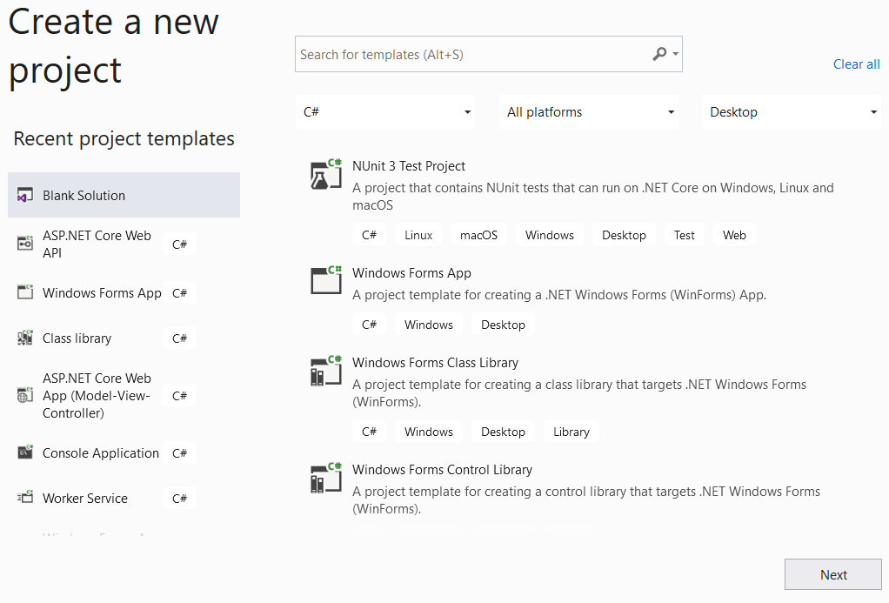

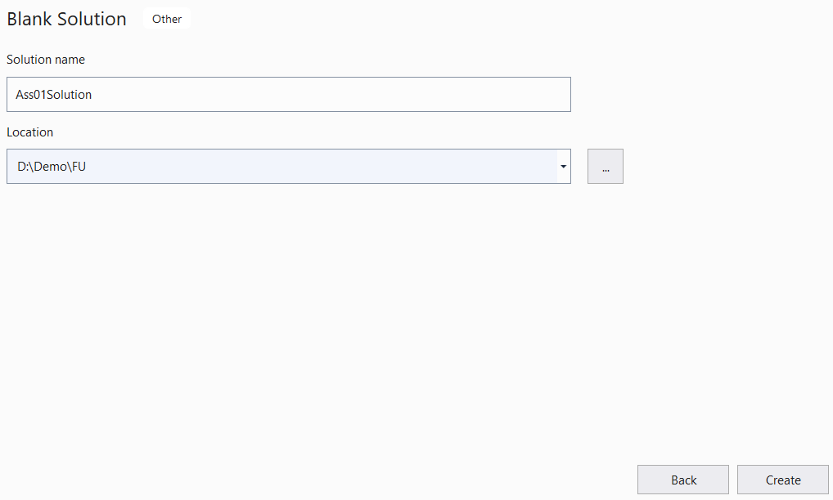

**Step 02.** Create a Class Library project named **DataAccess**

* 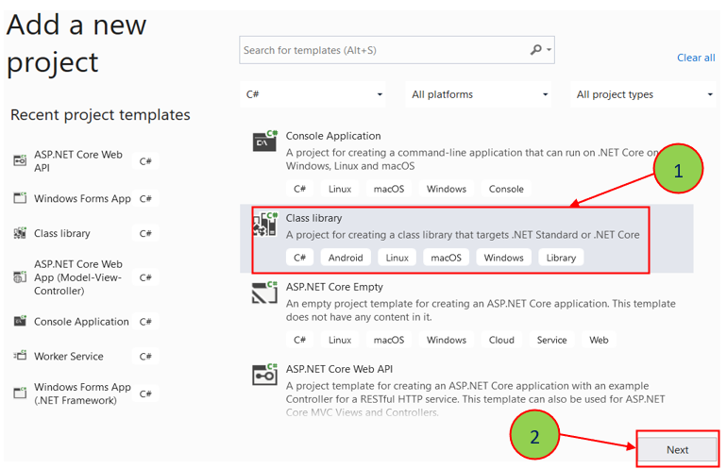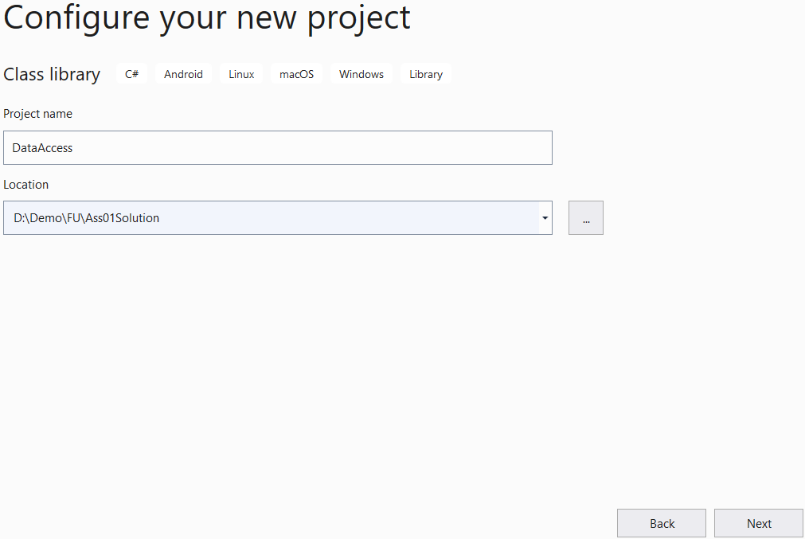From the File menu | Add | New Project, on the Add New Project dialog, select “Class Library” and performs steps as follows:

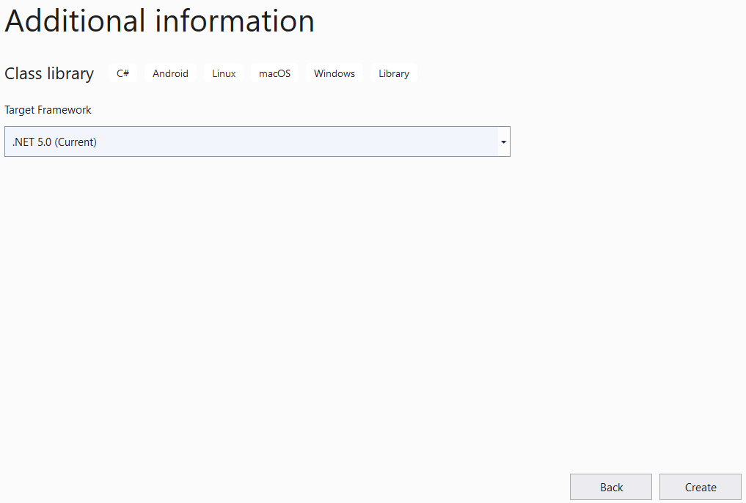

**Step 03.** Repeat **Step 02** to create a **BusinessObject** project.

**Step 04.** Create a Windows Forms project named **MyStoreWinApp**

* From the File menu | Add | New Project, on the Add New Project dialog, select “Windows Forms App” and performs steps as follows:

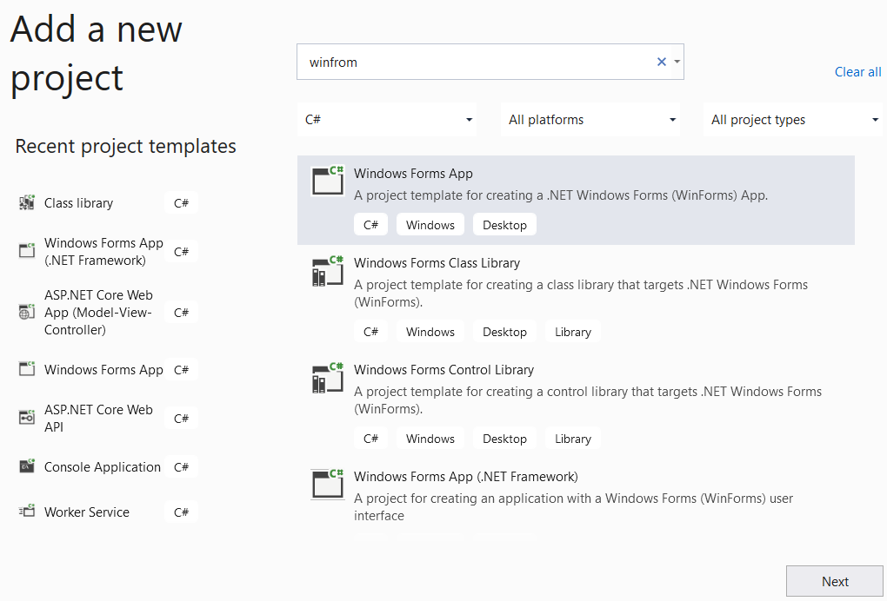

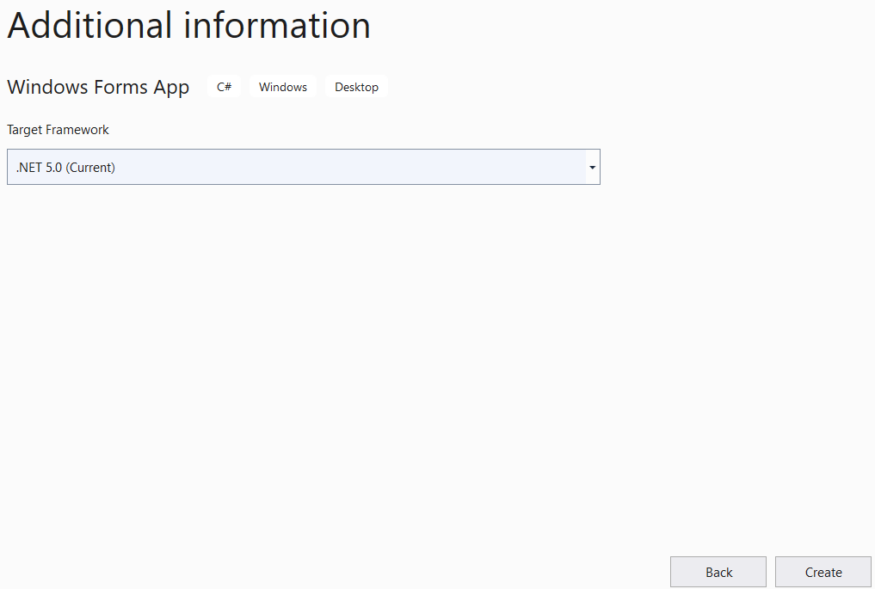

**Step 05**. Create folders and add class to the projects as follows:

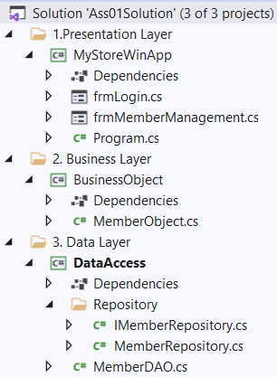

# Activity 02: Develop BusinessObject project [02 marks]

**Step 01**. Write codes to create a **Member** class and definition all data members

**Step 02**. Write codes to perform business rules for data members

# Activity 03: Develop DataAccess project [03 marks]

**Step 01**. Add a project reference to the **BusinessObject** project

**Step 02**. Write codes for **MemberDAO.cs**

**Step 03**. Write codes for **IMemberRepository.cs**

**Step 04**. Write codes for **MemberRepository.cs**

**Activity 04: Develop MyStoreWinApp project** [**03 marks]**

**Step 01**. Add a reference to **BusinessObject** and **DataAccess** project

**Step 02**. Design UI for **frmLogin.cs** form and write codes to perform authentication by **email** and **password.** If login is successful then show **frmMemberManagements.cs** formotherwise show an error message

**Step 03**. Design UI for **frmMemberManagements.cs** form and write codes to performs CRUD actions, Search action and Filter action, etc.

# Activity 05: Run the WinForms project and test all actions [01 mark]